H.T.NO:2303A51656
Batch 28
Task 1:
Prompt:
Apply AI to generate at least 3 assert test cases for is_strong_password(password) and implement the validator function.
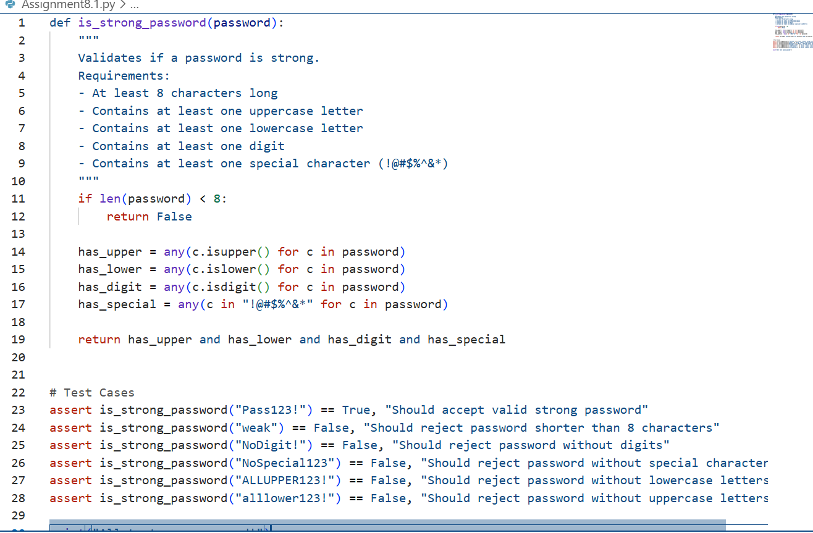
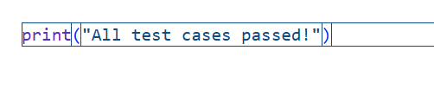
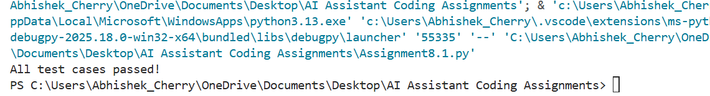
Task 2:
Prompt:
Use AI to generate at least 3 assert test cases for a
classify_number(n) function. Implement using loops.
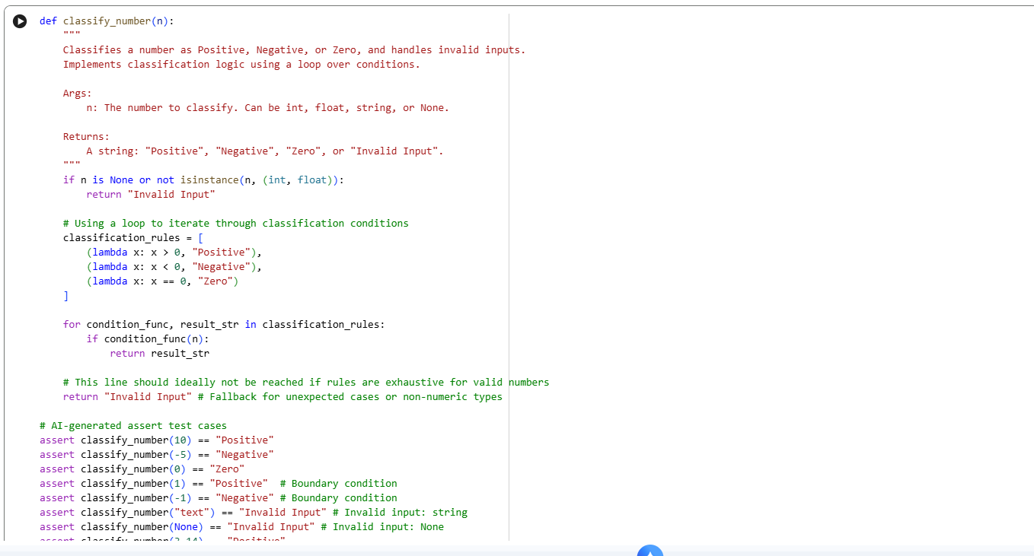
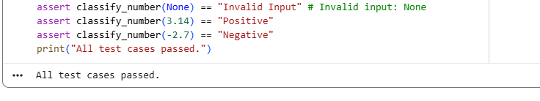
Task 3:
Prompt:
Use AI to generate at least 3 assert test cases for is_anagram(str1, str2) and implement the function.
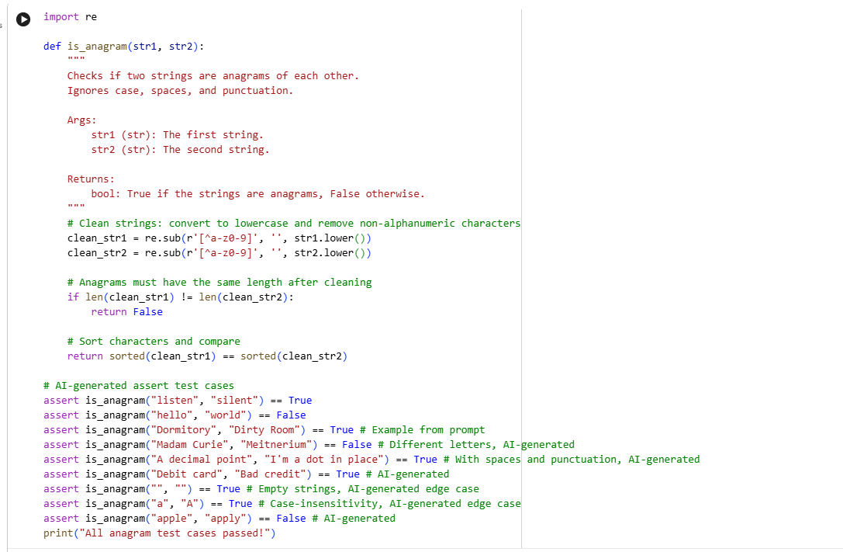
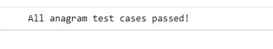
Task 4:
Prompt:
Ask AI to generate at least 3 assert-based tests for an Inventory class with stock management.
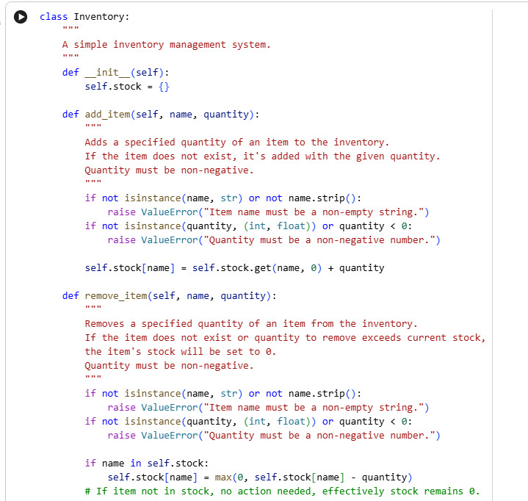
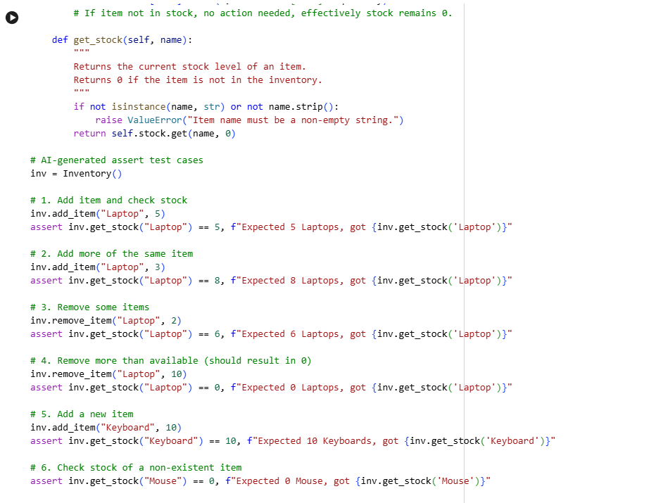
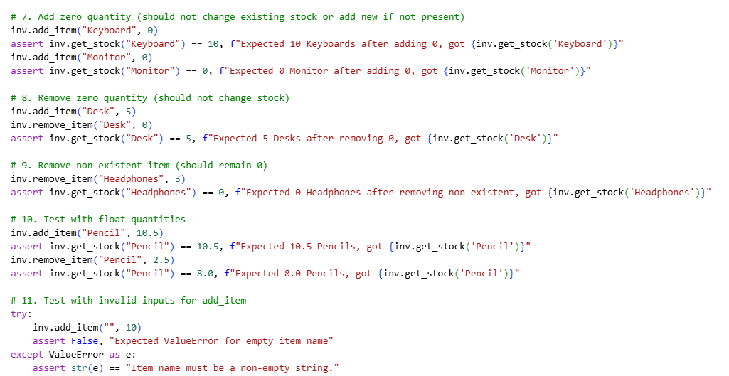
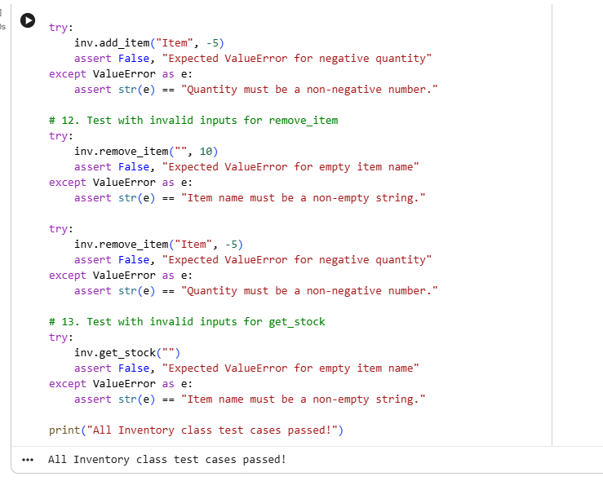
Task 5:
Prompt:
Use AI to generate at least 3 assert test cases for validate_and_format_date(date_str) to check and convert dates.
